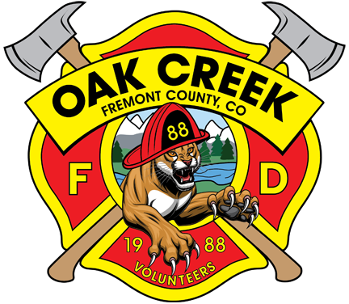
OAK CREEK GRADE VOLUNTEER FIRE DEPARTMENT
Neighbors Helping Neighbors

86 Piute Circle, Canon City, CO 81212 719-557-2925

Thank You for your increased support throughout this past year. Your donations have helped us to:
- Train 7 volunteers to become certified wildland firefighters. This increases their safety & success and moves us closer to becoming a recognized Fire Protection District.
- Purchase regulation WFF Boots for each of these 7 individuals. (@ $500/pair)
- Improve our radio communication system
- Provide supplies for on-going maintenance of our fleet of donated vehicles. (Labor is donated)
- Provide education to community members.

Our objectives continue to include:
- On-going training for volunteers.
- Providing our volunteer firefighters with better PPE and tools.
- Development of multiple water sources throughout the community.
- Identification of buildings that could house fire trucks during the winter so they can be kept full and ready for deployment.
- Acquisition of land and building our own fire house.
- Conduct a Community Wildfire Risk Assessment and develop a Community Wildfire Protection Plan.

Our Board recently met with the Fremont County Sheriff and Office of Emergency Management to identify criteria for attaining our own district recognition and utilization of FCSO equipment. There will be lots of work & on-going costs associated with these endeavors. Achieving these goals will increase safety for all of us and will have a positive impact on our insurance costs & availability.

Due to our remote location and intermix of private and heavily forested public lands, it is critical that we all work together for the safety of our community. What can you do to help?
- Mitigate your property
- Keep your eyes open, especially in the days following a storm. If you see smoke call it in. (911) The SO may be aware of a controlled burn in the area. If not, they need to know.
Also call Rick 719-557-2925 or Bob 719-661-9553
- Attend our meetings and join our email list to find out what is going on.
- Develop water sources for FD use on your own property.
- Volunteer ~ We could always use more firefighters but there are many other ways to help.
- KEEP DONATING ~ Please & Thank You!

Learn More:

https://www.facebook.com/profile.php?id=61575035699599

https://oakcreekfiredept.org/about-us-oak-creek-grade-vfd-community-led-neighbors-helping-neighbors/

